MQ Basic Knowledge

MQ Basic Knowledge 1
What is MQ? What does MQ use for? 2
MQ Component instruction 2
MQ Diagram 4
The Message Queuing Interface (MQI) 5
Message Type 6
MQ Commands 7

What is MQ? What does MQ use for?
Message queuing is a method of program-to-program communication. Programs within an
application communicate by writing and retrieving application-specific data (messages) to/from
queues, without having a private, dedicated, logical connection to link them.
Messaging means that programs communicate with each other by sending data in messages and
not by calling each other directly.
Queuing means that programs communicate through queues. Programs communicating through
queues need not be executed concurrently.

MQ Component instruction
Queue Manager
Queue Manager is a container which manager all the MQ objects like queue/channel/listeners and so on.The heart of MQSeries is the message queue manager (MQM), MQSeries’ run-time program. Its job is to manage queues and messages for applications. It provides the Message Queuing
Interface (MQI) for communication with applications. Application programs invoke functions of
the queue manager by issuing API calls.

Message Queues
Message queues are used to store messages sent by programs. There are local queues that are
owned by the local queue manager, and remote queues that belong to a different queue manager.
Transmission Queue is also a local queue.
Local Queue
A queue is local if it is owned by the queue manager to which the application program is
connected. It is used to store messages for programs that use the same queue manager. For
example, program A and program B each has a queue for incoming messages and another queue
for outgoing messages. Since the queue manager serves both programs, all four queues are local.
Cluster Queue
A cluster queue is a local queue that is known throughout a cluster of queue managers, that is, any
queue manager that belongs to the cluster can send messages to it without the need of a remote
definition or defining channels to the queue manager that owns it.
Remote Queue
A queue is “remote” if it is owned by a different queue manager. A remote queue definition is the
local definition of a remote queue. A remote queue is not a real queue. It is a structure that
contains some of the characteristics of a queue hosted by a different queue manager.
Transmission Queue
This is a local queue with a special purpose. A remote queue is associated with a transmission
queue. Transmission queues are used as an intermediate step when sending messages to queues
that are owned by a different queue manager.
Alias Queue
Alias queues are not real queues but definitions. They are used to assign different names to the
same physical queue. This allows multiple programs to work with the same queue, accessing it
under different names and with different attributes.
Initiation Queue
An initiation queue is a local queue to which the queue manager writes a trigger message when
certain conditions are met on another local queue, for example, when a message is put into an
empty message queue or in a transmission queue. Such a trigger message is transparent to the
programmer. Two MQSeries applications monitor initiation queues and read trigger messages,
the trigger monitor which starts applications and the channel initiator which starts the
transmission between queue managers.
Reply-to-Queue
A request message must contain the name of the queue into which the responding program must
put the reply message. This can be considered the “return address”. The name of this queue
together with the name of the queue manager that owns it is stored in the message header. This is
the responsibility of the application program.
Dead-Letter Queue
A queue manager must be able to handle situations when it cannot deliver a message. Here are
some examples:
• The destination queue is full.
• The destination queue does not exist.
• Message puts have been inhibited on the destination queue.
• The sender is not authorized to use the destination queue.
• The message is too large.
• The message contains a duplicate message sequence number.

Message channels
A message channel connects two queue managers via message channel agents (MCAs). Such
a channel is unidirectional. It comprises two message channel agents, a sender and a receiver,
and a communication protocol. An MCA is a program that transfers messages from a trans-
mission queue to a communication link, and from a communication link into the target queue.
For bidirectional communication you have to define two channel pairs consisting of a sender
and a receiver. Message channel agents are also referred to as movers.

MQ Diagram
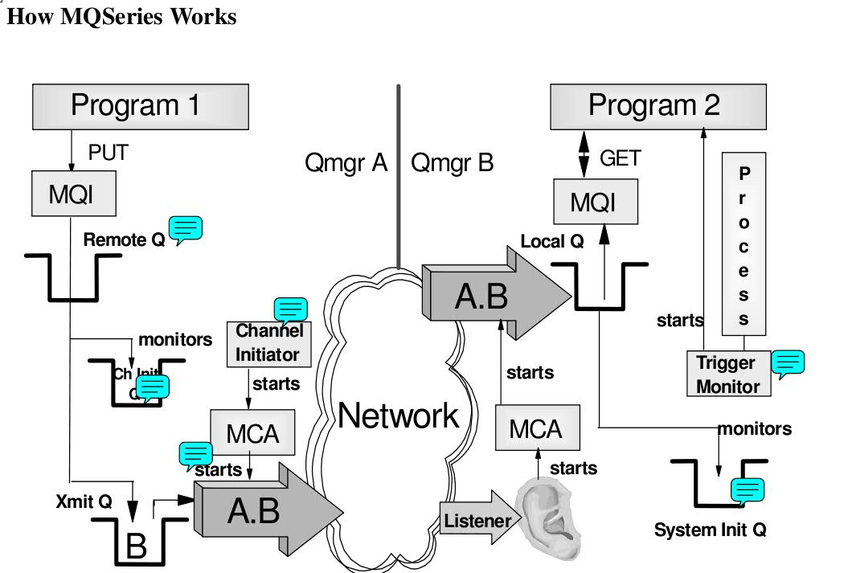
When the application program wants to put a message on a queue it issues an MQPUT API call.
This invokes the MQI. The queue manager checks whether the queue referenced in the MQPUT is
local or remote. If it is a remote queue, the message is placed into the transmission (xmit) queue.
The queue manager adds a header that contains information from the remote queue definition,
such as destination queue manager name and destination queue name.
Note: Each remote queue must be associated with an xmit queue. Usually, all messages destined
for one remote machine use the same xmit queue.
Transmission is done via channels. Channels can be started manually or automatically. To start a
channel automatically, the xmit queue must be associated with a channel initiation queue. Figure shows that the queue manager puts a message into the xmit queue and another message into the channel initiation queue. This queue is monitored by the channel initiator.
The channel initiator is an MQSeries program that must be running in order to monitor initiation
queues. When the channel initiator detects a message in the initiation queue, it starts the message
channel agent (MCA) for the particular channel. This program moves the message over the
network to the other machine, using the sender part of the unidirectional message channel pair.
On the receiving end, a listener program must have been started. The listener, also supplied with
MQSeries, monitors a specified port, by default, the port dedicated to MQSeries, 1414. When a
message arrives, it starts the message channel agent. The MCA moves the message into the
specified local queue using the receiver part of the message channel pair.
Note: Both channel definitions, sender and receiver, must have the same name. For the reply, you
need another message channel pair.
The program that processes the incoming message can be started manually or automatically. To
start the program automatically, an initiation queue and a process must be associated with the
local queue, and the trigger monitor must be running.
When the program starts automatically, the MCA puts the incoming message into the local queue
and a trigger message into the initiation queue. This queue is monitored by the trigger monitor.
This program invokes the application program specified in the process definition. The application
issues an MQGET API call to retrieve the message from the local queue.

The Message Queuing Interface (MQI)
A program talks directly to its local queue manager. It resides in the same processor or domain
(for clients) as the program itself. The program uses the Message Queuing Interface (MQI). The
MQI is a set of API calls that request services from the queue manager.
Note: When the connection between a client and its server is broken, no API calls can be
executed, since all objects reside in the server.
MQCONN:Connect to a queue manager
MQDISC:Disconnect from a queue manager
MQOPEN:Open a specific queue
MQCLOSE:Close a queue
MQPUT:Put a message on a queue
MQGET:Get a message from a queue
MQPUT1:MQOPEN + MQPUT + MQCLOSE
MQINQ:Inquire properties of an object
MQSET:Set properties of an object
MQCONN:Standard or fastpath bindings
MQBEGIN:Begin a unit of work (database coordination)
MQCMIT:Commit a unit of work
MQBACK:Back out
The most important ones are MQPUT and MQGET. The other calls are used less frequently.
Comments regarding several APIs follow:
MQCONN establishes a connection with a queue manager using the standard bindings.
MQCONNX establishes a connection with a queue manager using fastpath bindings. Fastpath
puts and gets are faster, but the application must be well behaved, that is, well tested. Application
and queue manager run in the same process. When the application crashes it takes the queue
manager down with it. This API call is new in MQSeries Version 5.
MQBEGIN begins a unit of work that is coordinated by the queue manager and that may involve
external XA-compliant resource managers. This API has been introduced with MQSeries Version
5. It is used to coordinate transactions that use queues (MQPUT and MQGET under syncpoint)
and database updates (SQL commands).
MQPUT1 opens a queue, puts a message on it and closes the queue. This is a combination of
MQOPEN, MQPUT and MQCLOSE.
MQINQ requests information about the queue manager or one of its objects, such as the number
of messages in a queue.
MQSET changes some attributes of an object.
MQCMIT specifies that a syncpoint has been reached. Messages put as part of a unit of work are
made available to other applications. Messages retrieved as part of a unit of work are deleted

Message Type
Persistent and Non-Persistent Messages
Application design determines whether a message must reach its destination under any
circumstances, or if it can be discarded when it cannot get there in time. MQSeries differentiates
between persistent and non-persistent messages. Delivery of persistent messages is assured; they
are written to logs to survive system failures.
The Message Descriptor
The table below contains some interesting attributes of the message descriptor. We mention them
here because they explain some of the functions the queue manager provides for you.
Version | Return Address
Message ID | Format
Persist/non-persist | Sender application and type
Priority | Reports Option
Date and time | Backout counter
Life time of a message | Segment/Group Information

• The version of the message descriptor depends on the MQSeries version and platform you
use. For the functions introduced with Version 5 additional fields were needed to keep information about segments and their order and distribution list information, to name a few. This enlarged structure carries the version number 2. Other queue managers who don’t support these functions treat the additional information as data.
• Message and/or correlation ID are used to identify a specific request or reply message. The programmer can move a value in one or both fields or have MQSeries create a unique ID for him or her. Before the programmer puts the request message in the queue he or she can save the ID(s) and use them in a subsequent get operation for the reply message. The program that receives the request message copies this information into the reply message. This allows the originating program (the one that gets the reply) to instruct MQSeries to look for a specific message in the queue instead of getting the first one in the queue.
• We discussed persistent and non-persistent messages earlier. Persistent messages always arrive at their destination, even when the system fails. They are “hardened”, that is, saved on disk. You can make a specific message persistent or all messages on a particular queue.
• You can assign a priority to a message and so control the order in which it is processed.
• The queue manager stores time and date when the MQPUT occurred in the message header. The time is in GMT and the year has four digits and so is Y2K compliant.
• You can also specify an expiration date. When this date is reached and an MQGET is issued, then the message will be discarded. There is no “daemon” that checks queues for expired messages. Expired messages can stay in a queue for weeks, until a program attempts to read it.
• The return address is very important for request/reply messages. You have to tell the server program where to send the reply message. Clients and servers have a one-to-many relationship and usually the server program cannot find out from the user data where the request message came from. Therefore, the client provides the reply-to queue and reply-to queue manager in the message header. The server uses this information when it performs the
MQPUT API call.
• In the format field, the sender can specify a value that the receiver can use to decide whether data conversion can be done or not. It is also used to indicate that there is an additional header (extension) present.
• The message also carries information about the sending application (program name and path)
and the platform it is running on.
• Report options and feedback code are used to request information, such as confirmation on
arrival or delivery, from the receiving queue manager. For example, the queue manager can
send a report message to the sending application when it puts the message in the target queue
or when the application gets it off the queue.
• Each time a message is backed out, the backout counter is increased. An application can check this counter and act on it, for example, send the message to a different queue where the reason for the backout is analyzed by an administrator.
• Message segmenting and grouping has been mentioned earlier. The queue manager uses the message header to store information about the physical message; for example, if it is a message group, the first or last segment, or which one in between.

MQ Commands
MQRC error code
Server name/Qmname/Qname

创建队列管理器
crtmqm –q QMgrName
-q是指创建缺省的队列管理器
删除队列管理器
dltmqm QmgrName
启动队列管理器
strmqm QmgrName
如果是启动默认的队列管理器，可以不带其名字
停止队列管理器
endmqm QmgrName 受控停止
endmqm –i QmgrName 立即停止
endmqm –p QmgrName 强制停止
显示队列管理器
dspmq –m QmgrName
运行MQSeries命令
runmqsc QmgrName
如果是默认队列管理器，可以不带其名字

往队列中放消息
amqsput QName QmgrName
如果队列是默认队列管理器中的队列，可以不带其队列管理器的名字
从队列中取出消息
amqsget QName QmgrName
如果队列是默认队列管理器中的队列，可以不带其队列管理器的名字

显示队列的所有属性
DISPLAY QUEUE（QNAME） [ALL]

显示队列的所选属性
DISPLAY QUEUE（QNAME） DESCR GET PUT
DISPLAY QUEUE（QNAME）MAXDEPTH CURDEPTH

显示队列管理器的所有属性
DISPLAY QMGR [ALL]

显示进程定义
DISPLAY PROCESS（PRONAME）

更改属性
ALTER QMGR DESCR（‘NEW DESCRIPTION’）
ALTER QLOCAL（QNAME） PUT（DISABLED）
ALTER QALIAS（QNAME） TARGQ（TARGQNAME）

删除队列
DELETE QLOCAL（QNAME）
DELETE QREMOTE（QRNAME）

清除队列中的所有消息
CLEAR QLOCAL（QNAME）

-------------------------------------------------------------------------------------------

启动通道
runmqchl –c ChlName –m QmgrName

启动侦听
runmqlsr –t TYPE –p PORT –m QmgrName

停止侦听
endmqlsr -m QmgrName

MQ命令
定义死信队列
DEFINE QLOCAL（QNAME） DEFPSIST（YES） REPLACE
设定队列管理器的死信队列
ALTER QMGR DEADQ（QNAME）
定义本地队列
DEFINE QL（QNAME） REPLACE
定义别名队列
DEFINE QALIAS(QALIASNAME) TARGQ(QNAME)
远程队列定义
DEFINE QREMOTE（QRNAME） +
RNAME（AAA） RQMNAME（QMGRNAME） +
XMITQ（QTNAME）
定义模型队列
DEFINE QMODEL（QNAME） DEFTYPE（TEMPDYN）
定义本地传输队列
DEFINE QLOCAL(QTNAME) USAGE(XMITQ) DEFPSIST(YES) +
INITQ（SYSTEM.CHANNEL.INITQ）+
PROCESS(PROCESSNAME) REPLACE

创建进程定义
DEFINE PROCESS（PRONAME） +
DESCR（‘STRING’）+
APPLTYPE（WINDOWSNT）+
APPLICID（’ runmqchl -c SDR_TEST -m QM_ TEST’）
其中APPLTYPE的值可以是：CICS、UNIX、WINDOWS、WINDOWSNT等

创建发送方通道
DEFINE CHANNEL（SDRNAME） CHLTYPE（SDR）+
CONNAME（‘100.100.100.215(1418)’） XMITQ（QTNAME） REPLACE
其中CHLTYPE可以是：SDR、SVR、RCVR、RQSTR、CLNTCONN、SVRCONN、CLUSSDR和CLUSRCVR。

创建接收方通道
DEFINE CHANNEL（SDR_ TEST） CHLTYPE（RCVR） REPLACE

创建服务器连接通道
DEFINE CHANNEL（SVRCONNNAME） CHLTYPE（SVRCONN） REPLACE

常用补充命令
显示队列管理器 dspmq
显示文件名 dspmqfls

启动本地队列管理器 strmqm
结束本地队列管理器 endmqm
启动通道启动进程 runmqchi/runmqchl

